Whitefish Mountain Resort has added a new lift that increased operational costs by an additional $1,540,000 and our investors want to keep the profits around 9.2% with the ability to grow in the future. In order to do this, we looked at multiple resorts and compared information as well as came up with projected figures.

Weekend ticket prices

The data has shown that increasing the adult weekend pricing for lift tickets should increase the profit margin, however we recommend doing a multilayered approach. First we will go over ticket pricing, this should keep the profit margin for research into other solutions..

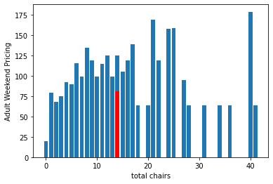

Our current pricing is lower than other locations, which have their prices up to $125 for the same amount of chairs. By this factor, we have some room to move and improve during later updates and reviews in the future.

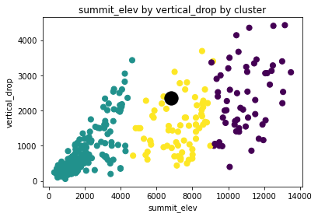

The cluster graph above shows the competitions summit elevation and vertical drop. We are basically in the middle in terms in drop and elevation, which is good as it gives a higher variety in customers, leading to a good volume as well. The question is how do we compare in prices to other resorts. Below are two cluster charts that convey where we stand with the competition in terms of the weekend ticket prices.

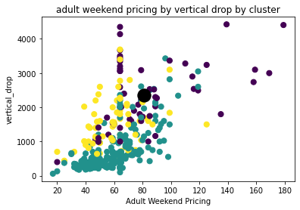

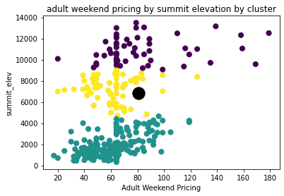

Both cluster graphs show that we are higher in price than most of our competition, however that can be due to resort standards or other factors, but it does show that we cannot allow the prices to get to a point that customers begin leaving bad reviews. A satisfactory raise to these prices is from our current rate of $81 to $88.37, which will keep us in an area that will not discomfort our guests and leave an area for growth.